Chapter 10 Section 1 – Describing Motion
Objective(s): Review motion in one dimension
Vocabulary Terms: 1. Distance 2. Displacement 3. Speed 4. Average speed 5. Instantaneous speed 6. Velocity
I. Motion
- Motion occurs when an object changes its position.
- Describing motion!
  - Relative motion – how are you moving relative to your desk? How are you moving relative to Mars?
  - Distance – How far an object has moved?
  - Displacement – the distance and direction of an objects change in position from a starting point.
- Describing Speed!
  - Speed – the distance an object travels per unit of time = rate.
  - Calculating speed
    - Speed = distance / time
    - s=d/t
    - SI units for speed = meters/second = m/s
  - Measuring speed
1. Constant speed
a. Example = light
- Changing speed
- Average speed
a. total distance/total time
4. Instantaneous speed a. A speed at any given point in time.
II. Graphing Motion a. Distance-time graphs display the motion of an object over a period of
time. i. Example:
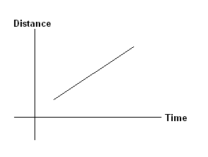
- Steeper the graph (greater slope) the higher the speed.
- Changing speed like standing still results in a graph with different slopes:
III. Velocity
- Speed with a direct component.
- Velocity can change even as speed does not change because the direction can be constantly changing. See the velocity vector on the following graph:
Section 2: Acceleration
Vocabulary Terms: 1. Acceleration
I. Acceleration = The rate of change of velocity and occurs when an object changes its speed, its direction, or both.
a. Positive acceleration = speed increases.
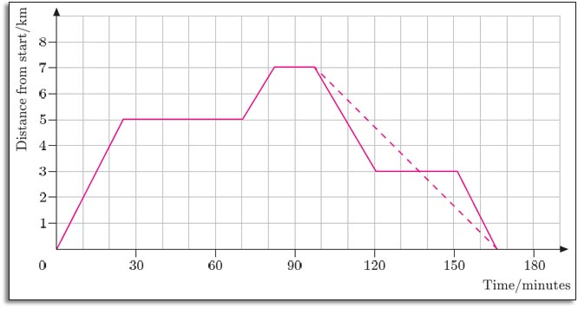
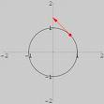
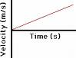
b. Negative acceleration = speed decreases.
c. Changing direction while keeping the speed constant also results in an acceleration. Examples:
1. Earth is accelerating constantly as it orbits the sun in a nearly circular
path. II. Calculating Acceleration
a. Acceleration = change in velocity / time 1. Change in velocity = final velocity – initial velocity = vf – vi
b. a=(vf–vi)/t c. SI units for acceleration = meters/second/second = m/s2 (meters per second squared).
Section 3: Motion and Forces
Vocabulary Terms: 1. Force, 2. Net force, 3. Inertia
I. Motion and Forces a. Force = a push or pull that one body exerts on another.
1. Forces can cause a change in motion of objects. 2. Forces do not always change velocity. 3. Forces can also cancel each other out.
b. Net Force = Two or more forces act on an object at the same time. 1. Unequal forces in opposite directions results in a net force in the direction of the larger force = unbalanced force.
c. Inertia and Mass 1. Newton’s First Law of Motion (Law of Inertia) Sir Isaac Newton (1642-1727)
a. Definition = an object moving at constant velocity keeps moving at that velocity unless a net force acts on it.
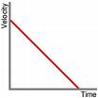
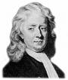
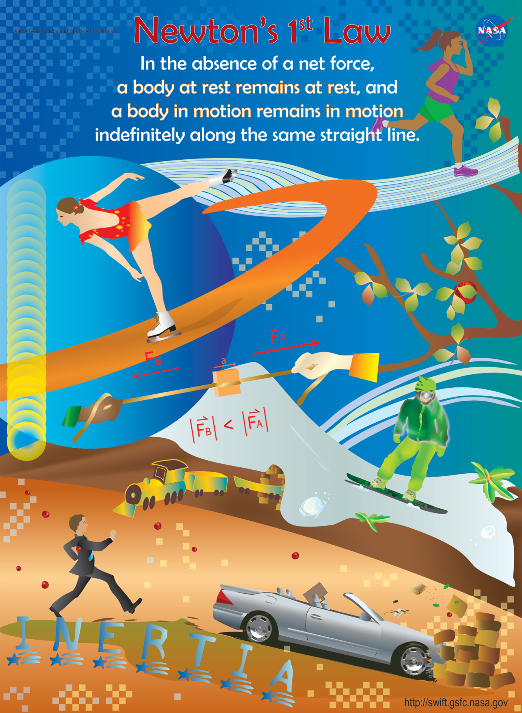
b. Examples: 1. An object at rest stays at rest unless a net force acts on it. 2. Car crash: occupants keep moving forward even though the car is slowing. Passengers will continue moving forward will the force of the steering wheel, dashboard, or windshield acts as a net force against them.

